Doruk ÖZER

70192

Homework 4

First of all I read specified chapter in the book. Then I realized we wont be doing learning parameters process since we will be using non-parametric regression methods.

I wrote the Regrossagram’s g(x) function by calculating the taking the x’s in the same bin and I found the g(x) for each bin by implementing the function in the cheat sheet. (Lab 6 also helped me to understand the basic calculations). I wrote this part differently more likely to java language with for loops. I hold an np array for each bin and sum the results to this array for each bin.

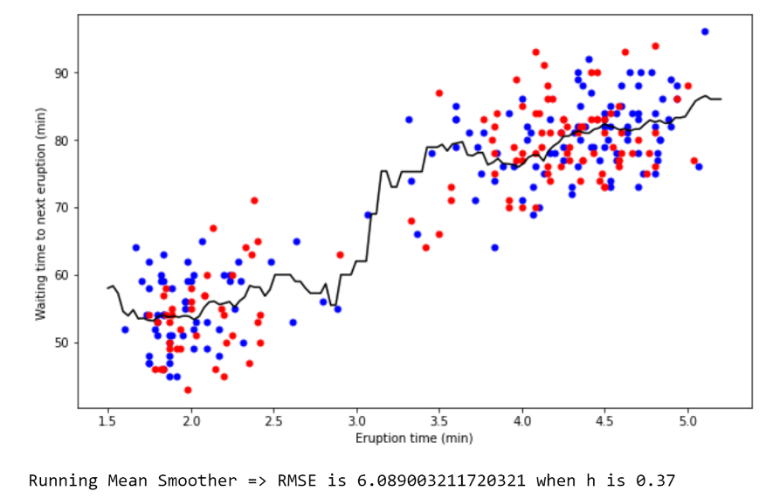

For running mean smoother I took the expression **u** out of the absolute value and find a function same as the lab6 then I calculated the denominator and numerator in the formula in different np arrays and divided them.

Lastly for Kernel Smoother I changed the lab6 parts of the Kernel Estimator. I multiplied by the y values and I didn’t divide the result with the Nh. I hold the numerators and denominators in different arrays and divided them

